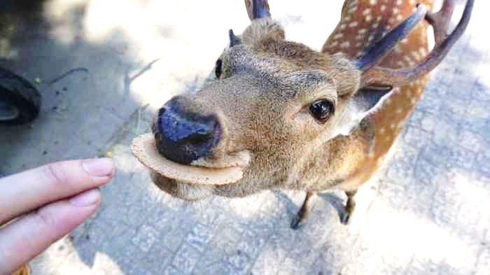
In Search of Crackers?
Nara is one of the ❶( old ) cities in Japan. In Nara, there are many famous temples and shrines such as Todai-ji, Kasuka-taisha, etc. Nara is ❷( visit ) by many tourists. The number of the tourists was about 17 million people included about 3 million foreign tourists in 2018. Many tourists enjoy ❸( give ) Shika-senbei to the Nara Park’s deer. In 2019, about 1,400 deer live around the Nara Park. Now they are ❹( see ) in streets away from the home(Nara Park) more often than before. Some experts think they are ❺( walk ) around in search of crackers ❻______________ they cannot get them from tourists.
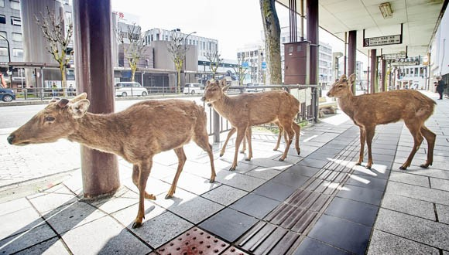
How often does the bus come?
Why don’t we ride on a bus!

That’s a nice idea!

*Todai-ji 東大寺 *Kasuga-taisha 春日大社 *tourist 観光客 *included 含めて *expert 専門家

Question 1 ❶❷❸❹❺の（ ）の中の語を適当な形に直して書きなさい。
❶ ❷
❸ ❹
❺

Question 2 下線部❻に適当な英語１語を書きなさい。

In Search of Crackers?
Nara is one of the oldest cities in Japan. In Nara, there are many famous temples and shrines such as Todai-ji, Kasuka-taisha, etc. Nara is visited by many tourists. The number of the tourists was about 17 million people included about 3 million foreign tourists in 2018. Many tourists enjoy giving Shika-senbei to the Nara Park’s deer. In 2019, about 1,400 deer live around the Nara Park. Now they are seen in streets away from the home(Nara Park) more often than before. Some experts think they are walking around in search of crackers because they cannot get them from tourists.
How often does the bus come?
Why don’t we ride on a bus!

That’s a nice idea!

*Todai-ji 東大寺 *Kasuga-taisha 春日大社 *tourist 観光客 *included 含めて *expert 専門家

Question 1 ❶❷❸❹❺の（ ）の中の語を適当な形に直して書きなさい。
❶ ❷
❸ ❹
❺

Question 2 下線部❻に適当な英語１語を書きなさい。

